**24 Oct 2014** **The Weekly Bulletin of Rotary Club of Kathmandu Mid-Town** **bc-16/10.014**

|  |
| --- |
|  |

District: 3292 Web:www.rotarymidtown.org.np Club Id: 26776

**OCTOBER IS VOCATIONAL SERVICE MONTH**

**Celebrating**

**25 Years in Rotary**







**HAPPY TIHAR 2071**

**May This Festival Bring You Happiness, Happiness, and Happiness Today, Tomorrow, Every Day**

Friday, 17 October :

Regular weekly meeting # 1250 of the Club was held on Friday morning at Hotel Annapurna.

Extracts of the Meeting Minutes # 1250 are given below:

“7. A short talk by Ananta Baidya on "Pre-disaster mitigation, Disaster Risk Reduction, Enhanced & Inclusive Public Safety for All (Able & People with Disabilities.)". The speaker was introduced by Rtn Govinda. Professional engineer Ananta Baidya talked about the need to make Kathmandu earthquake and fire proof. He showed photos of several alarming trends in poor construction techniques being used throughout the city and emphasised the need for good engineering practices especially for the construction of high-rise buildings. Both structural and non-structural approaches need to be in place; the special measures to implement these approaches should be taught to local engineers during their schooling. After a lively question and answer session the vote of thanks was offered by Rtn HE Asko.”

“8.Information sharing/AOB.

- The Board Meeting will be hosted by Rtn Lisa on 28 October

- Members present: na ”

# Weekly Meetings and Programs :

|  |  |  |
| --- | --- | --- |
| Date | Program/Speaker | Topic of Presentation |
| 24 October | TBA | TBA |
| 31 October |  |  |
| 7 November |  |  |
|  |  |  |

Friday, 24 October :

TBA.

THE WHITE HOUSE HONORS ROTARY WOMEN FOR THEIR HUMANITARIAN SERVICE**:**

Senior Rotary leaders gathered Tuesday at the

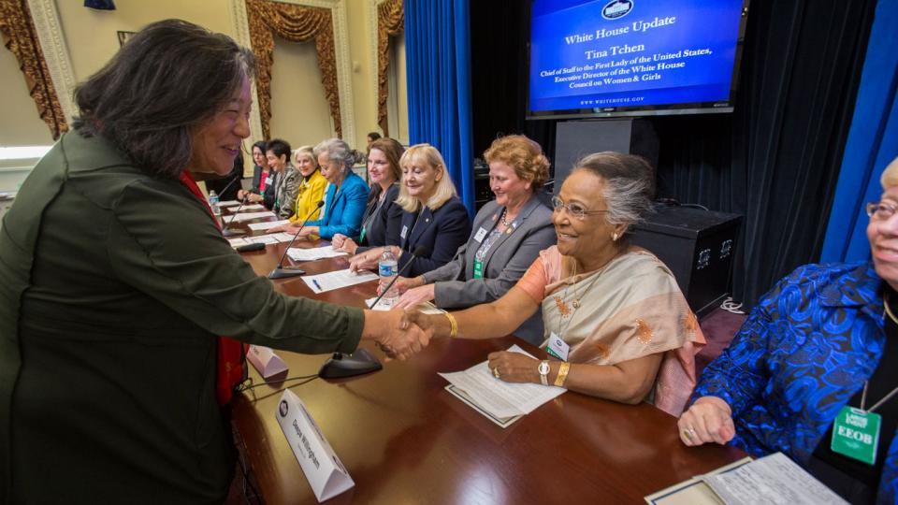

Tina Tchen, assistant to President Barack Obama, and chief of staff to First Lady Michelle Obama, thanks the Rotary honorees for their humanitarian work.

White House to honor [10 women](https://www.rotary.org/myrotary/en/history-women-rotary) for their service

projects, [an event](https://www.rotary.org/myrotary/en/rotary-days) attended by members of U.S.

President Barack Obama's senior staff.

The Rotary members presented their projects, in

the hopes of creating new inroads for government

partnerships and support.

"This is recognition of the great work that they do

but also serves as a great vehicle to inspire others

to do similar kinds of things," said Rotary General

Secretary John Hewko. "One of the things we're

doing a better job of is sharing our story to the non-

Rotary world."

The honorees were selected by Rotary senior leaders

and endorsed by the White House from clubs around

the U.S. but their projects touch lives across the globe.

*Source: Adam Ross/Internet News*

**Rotary’s Response To Ebola Outbreak**

Rotary continues to follow the developments surrounding the Ebola outbreak in West Africa and advice of the World Health Organization and U.S. Centers for Disease Control and Prevention, our partners in international public health.

Strengthening the health infrastructure and supporting and sustaining the deployment of government health workers throughout these outbreak areas are greatly needed. Although Rotary has limited opportunities to respond at a corporate level, our strength as an organization is firmly rooted in the grassroots response of Rotary clubs and Rotarians.

Clubs around the world are creating or joining coalitions that are raising funds as well as purchasing and shipping safety equipment and supplies. If you want to let others know about your club project, you can post it on Rotary Ideas, Rotary’s crowd sourcing tool.  Club officers can request partners, online contributions, volunteers, and in-kind donations for their projects. While only Rotary projects can request resources, anyone – including the public – can visit the site and donate.

The Rotary Foundation continues to support long-term sustainable health care projects through global grants.

Questions about contributing to Ebola relief efforts should be sent to [relief@rotary.org](mailto:relief@rotary.org)

*Source: RI News*

24 October : United Nations Day







On United Nations:

“[One of my earliest memories is walking up a muddy road into the mountains. It was raining. Behind me, my village was burning. When there was school, it was under a tree. Then the United Nations came. They fed me, my family, my community.](http://www.brainyquote.com/quotes/quotes/b/bankimoon643810.html)” - [*Ban Ki-moon*](http://www.brainyquote.com/quotes/authors/b/ban_kimoon.html)

“[The United Nations, whose membership comprises almost all the states in the world, is founded on the principle of the equal worth of every human being.](http://www.brainyquote.com/quotes/quotes/k/kofiannan399979.html)” - [*Kofi Annan*](http://www.brainyquote.com/quotes/authors/k/kofi_annan.html)

“[The United Nations is the preeminent institution of multilateralism. It provides a forum where sovereign states can come together to share burdens, address common problems, and seize common opportunities. The U.N. helps establish the norms that many countries - including the United States - would like everyone to live by.](http://www.brainyquote.com/quotes/quotes/s/shashithar627925.html)” - [*Shashi Tharoor*](http://www.brainyquote.com/quotes/authors/s/shashi_tharoor.html)

“[The new millennium began with a great global dream. World leaders gathered at the United Nations in 2000 and adopted, among others, a historic goal to reduce poverty by half by 2015. Never in human history had such a bold goal been adopted by the entire world in one voice, one that specified time and size.](http://www.brainyquote.com/quotes/quotes/m/muhammadyu593362.html)” - [*Muhammad Yunus*](http://www.brainyquote.com/quotes/authors/m/muhammad_yunus.html)

*Source: Internet News*

**Celebrate Tihar : Best Greetings to you all !**

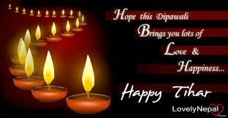

Tihar  is a five-day-long Hindu festival celebrated in [Nepal](http://en.wikipedia.org/wiki/Nepal). All Hindu ethnic groups celebrate this with their own variation. Tihar in general signifies the festival of lights, where diyas are lit both inside and outside the houses to make it illuminate at night. The five-day festival is considered to be of great importance as it shows reverence to not just the humans and the Gods, but also to the animals like crow, cow and dog, who maintain an intense relationship with the humans.

The first day of the festival is called *Kaag Tihar* or Kaagpuja (worship of the crows). The cawing of the crows symbolizes sadness and grief in the Hindu mythology, so the devotees offer the crows food to avert grief and deaths in their homes. Crows are offered food before anyone in home takes morning meal.

The second day is called *Kukur Tihar* or *Kukurpuja* (worship of the dogs). Dog is believed to be messenger of Lord Yamaraj, the God of death.

The morning of third day is *Gai Tihar* (worship of the cow). In Hindu religion, cow signifies prosperity and wealth. In the evening Luxmi, the goddess of wealth is thanked for all the benefits that were bestowed on the families by lighting oil lamps or candles on doorways and windows to welcome prosperity and well being. At night the girls enjoy dancing and visiting all the houses of the neighborhood with musical instruments singing and dancing known as [*Bhailo*](http://en.wikipedia.org/wiki/Bhailo) all night long collecting money as tip from houses and share the bounty amongst themselves. From the third day onwards tihar is celebrated by playing Deusi and Bhailo along with light and fireworks. . Deusi is mostly sung by the boys while the Bhailo is sung by the girls.

On the fourth day of Tihar, there are three different known pujas, depending on the people's specific cultural background: Mhapuja (worship of self), *Gorupuja* (worship of the oxen), *Govardhan Puja*,(cowdung, representing mountain). The Newar community celebrate Mhapuja. The day is the first day of New Nepal Sambat Year.

The fifth and last day of Tihar is *Bhai Tika*, where sisters provide [*tika*](http://en.wikipedia.org/wiki/Tilaka) to brothers, to ensure long life, and thank brothers for protection they provide.



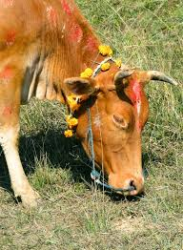

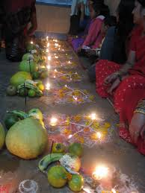

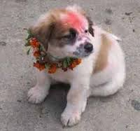

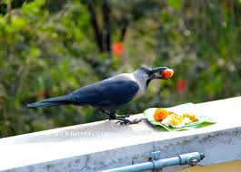

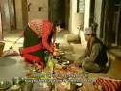

*Source: Internet News*

**Committee Chairs’ Column:** *(This column is for use by chairpersons of 5 permanent committees: Club Administration, Membership, Public Relations, Service Projects, and the Rotary Foundation)*

On Lighter Side :



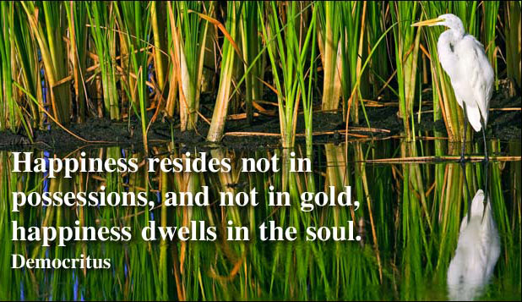

**A THOUGHT FOR TODAY:**

[**[Life is just a short walk from the cradle to the grave](http://www.brainyquote.com/quotes/quotes/g/georgebern102967.html" \o "view quote)**](http://www.brainyquote.com/quotes/quotes/b/brucelee384114.html)

**[and it sure behooves us to be kind to one another along the way](http://www.brainyquote.com/quotes/quotes/g/georgebern102967.html" \o "view quote)**[.](http://www.brainyquote.com/quotes/quotes/g/georgebern102967.html" \o "view quote)

[- Alice Childress, playwright, author, and actor (1916-1994)](http://www.brainyquote.com/quotes/quotes/g/georgebern102967.html" \o "view quote)

*[Courtsey: Isabella Khadka](http://www.brainyquote.com/quotes/quotes/g/georgebern102967.html" \o "view quote)*

**Members’ Corner:** *(This column is for Club members to express anything they would like in matter of Club activities, Club administration, Club issues or on Breakfast Chatter, or on anything else that would be of interest to fellow members.)*



Today’s challenge is tomorrow’s opportunity. Decide now that you are going to be active,

do your very best, have nothing to regret. And the third thing … very simple: Be a friend.

**RI President GARY C.K. HUANG**

Please send information on club activities, progress reviews on service projects, relevant photos etc to:

BC Editor: RR Shrestha email: rryesrr@gmail.com

## 24 October 2014 The Weekly Bulletin of Rotary Club of Kathmandu Mid-Town bc-16/10.014